KYRA Person Height Measurement Module
Complete Technical Documentation
Project Overview The KYRA Person Height Measurement Module is a fully marker-free, single-webcam height measurement system built in Python using MediaPipe Pose and OpenCV. It estimates the real-world height (in centimetres) of a standing person using only a standard USB or laptop webcam — no depth sensors, no AR markers, no external hardware.

Key Features:
• Marker-free detection — uses AI body keypoints (no physical markers)
• Two calibration methods — calibrate with a physical object OR directly using a person of known height • On-screen visual feedback — height, position status, and detecting indicators overlaid on the live camera view
• Rolling median smoothing — reduces measurement jitter using a 10-frame rolling median
• Persistent calibration — scale factor is saved to a JSON config file; works across sessions and across different locations (home, office)
• Validation suite — automated accuracy sweep with PASS/FAIL report
• Distance sensitivity testing — benchmarks accuracy across close, medium, and far distances
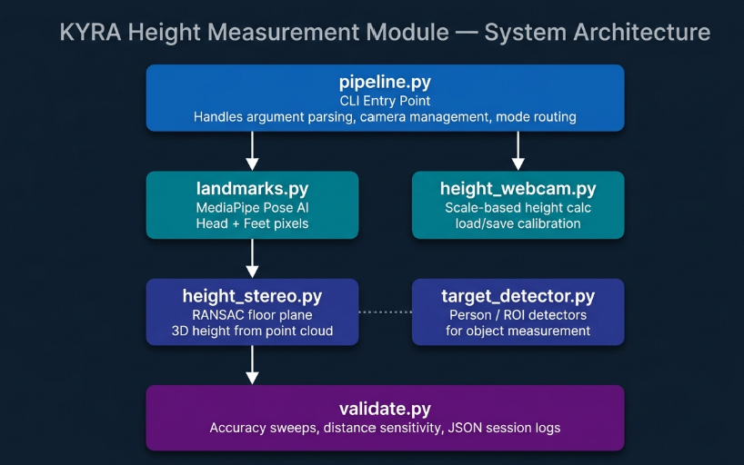

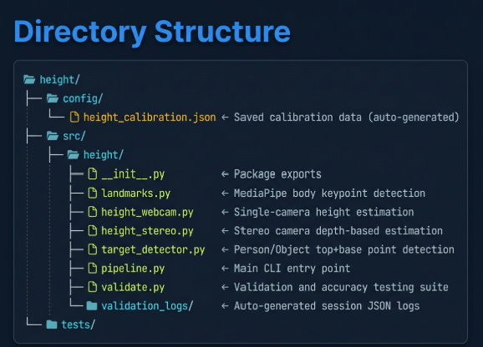

Module Descriptions:
1. landmarks.py
Purpose: Uses MediaPipe Pose to detect body keypoints and compute precise head-top and feet-ground pixel coordinates.
Key Design Decisions:
• Head Top (Dynamic Scaling): The head top is estimated by shifting the nose point upward by 50% of the nose-to-shoulder vertical distance. This is anatomically correct and automatically scales for short and tall people, eliminating the 2–3 cm height-dependent bias that a fixed pixel offset would create
• Feet Ground Point (Absolute Lowest): The feet Y-coordinate is the maximum Y value (lowest point on screen) among 6 landmarks: left/right ankles (27, 28), left/right heels (29, 30), and left/right toes (31, 32). This ensures the tracking line reaches the floor contact level.
• Shoulder Visibility Check: Both shoulders must be detected at ‡ 50% confidence for the dynamic head-shift calculation to work.
Output: {"head": (x, y), "feet": (x, y)} pixel coordinates, or None if landmarks are not visible.

2. height_webcam.py

Purpose: Calculates physical height in centimetres from pixel coordinates using a pre-calibrated pixels-per-cm scale factor.
Height Calculation Formula:
height_cm = (|head_y - feet_y| / pixels_per_cm) + 1.0 The +1.0 cm is a residual correction for minor perspective projection and hair volume effects.
Calibration Storage (config/height_calibration.json):
{ "pixels_per_cm": 8.52,
"calibrated_base_y": 447,
"saved_at": "2026-07-15T14:30:00"
}
• pixels_per_cm — the core scale factor
• calibrated_base_y — the Y-pixel of the floor level during calibration (used for position guidance)

Key Functions:

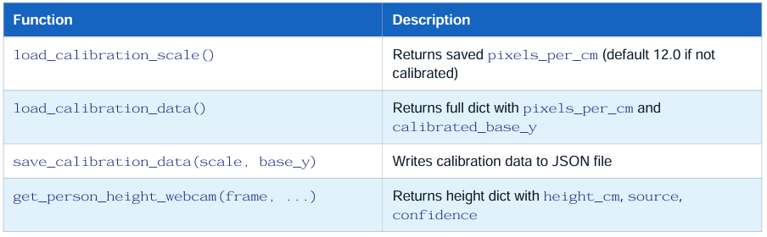

3. height_stereo.py
Purpose: Provides stereo-camera height estimation using RANSAC floor-plane fitting on 3D point clouds.
Method:
1. Takes an RGB-D point cloud from stereo calibration.
2. Fits a ground plane using RANSAC to identify the floor level.
3. Measures the perpendicular 3D distance from the head point to the fitted floor plane.
4. Subtracts a 1.5 cm hair volume correction.
Key Functions:
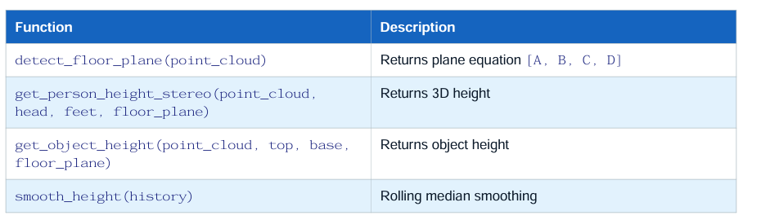

4. target_detector.py

Purpose: Wraps landmark-based and ROI-based detection into a common interface for the universal pipeline
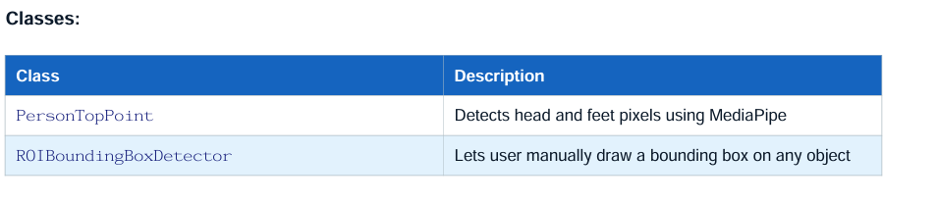

5.pipeline.py
Purpose: The main CLI entry point. Orchestrates camera setup, calibration, mode routing, and live display.
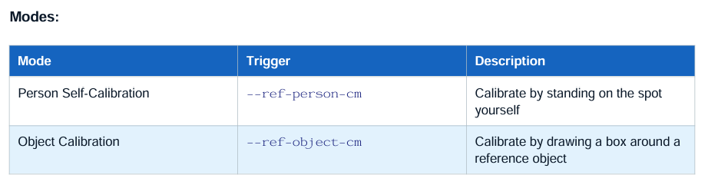

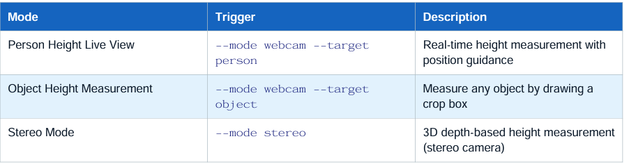

Key Functions:

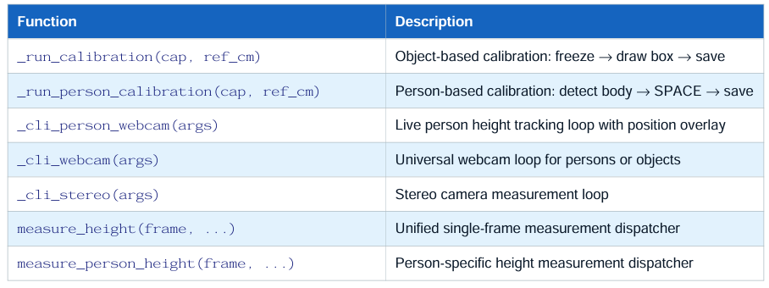

6. validate.py
Purpose: Automated accuracy evaluation suite with structured JSON logging
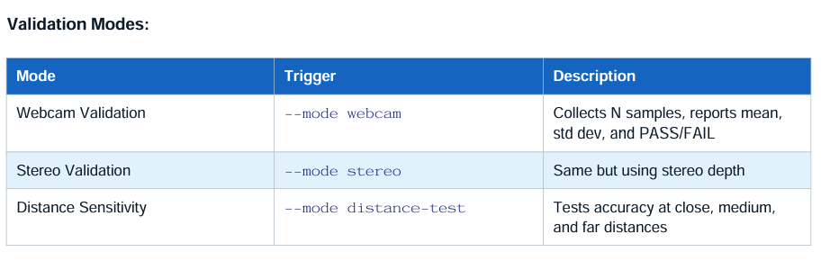

Output JSON Log Structure:
{
"summary":
{ "mode": "webcam",
"known_height_cm": 146.0,
"mean_measured_height_cm": 146.8,
"std_dev_cm": 0.3,
"absolute_error_cm": 0.8,
"error_percentage": 0.55,
"passed": true,
"n_samples": 20 },
"samples": [...]
}

How It Works
Step 1: Camera Frame
Capture Every frame from the webcam is captured as a BGR NumPy array via cv2.VideoCapture.
Step 2: Landmark Detection (MediaPipe Pose)
The frame is converted from BGR to RGB and processed by MediaPipe Pose (model_complexity=1).
This returns 33 body landmarks with normalised (0–1) x, y coordinates and visibility scores.
Step 3: Head Top Estimation
shoulder_y = mean of left_shoulder.y and right_shoulder.y
shift = 0.50 x |nose.y - shoulder_y| x frame_height
head_y = nose.y x frame_height – shift
This is proportional to the person's on-screen size — automatically correct for any height or distance.
Step 4: Feet Ground Estimation
foot_y = max(
left_ankle.y, right_ankle.y,
left_heel.y, right_heel.y,
left_toe.y, right_toe.y
) x frame_height
This finds the absolute lowest visible point of the foot, reaching the actual floor contact level.
Step 5: Height Calculation
pixel_span = |head_y - foot_y|
height_cm = (pixel_span / pixels_per_cm) + 1.0
Step 6: Rolling Median Smoothing
The height is appended to a rolling deque of the last 10 values. The on-screen display always shows the median of this window to filter out single-frame jitter
Step 7: Position Guidance
The saved calibrated_base_y is compared to the current feet[1]:
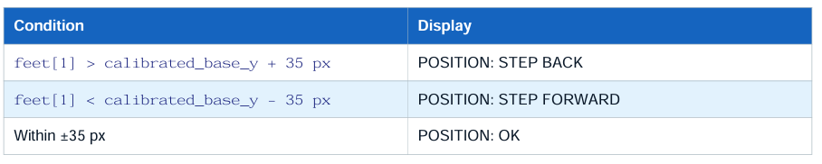
Calibration Methods
Method A: Person Self-Calibration (Recommended)
Command: python src/height/pipeline.py --ref-person-cm (enter actual height)
How it works:
1. The camera detects your full body in the frame.
2. It measures your current pixel span (head to feet).
3. It solves for pixels_per_cm such that the formula outputs exactly your known height: pixels_per_cm = pixel_span / (ref_height - 1.0)
4. The result is saved to config/height_calibration.json.
Why this is most accurate: The scale factor is derived from your exact body at your exact standing distance, with zero perspective error.

Method B:Object Calibration
Command: python src/height/pipeline.py --ref-object-cm (object height)

How it works:
1. Camera live feed opens. Press SPACE to freeze the frame.
2. Draw a bounding box from the top to the bottom of the reference object.
3. Press ENTER to save.
4. The calibration computes: pixels_per_cm = box_height_pixels / ref_object_cm
5. Both the scale and the base Y-coordinate (ry + rh) are saved.
Important: Place the reference object on the floor on the exact standing spot. Holding it in your hand will cause a perspective error because your hand is closer to the lens than your feet.

Calibration Portability
The calibration file is stored at config/height_calibration.json.
You can:
• Re-run calibration in a new location (office, home) at any time — it overwrites the old file.
• Use the same calibration file as long as the camera position and angle remain unchanged.
• Calibrate once per measurement session/location for the best accuracy.

On-Screen Indicators
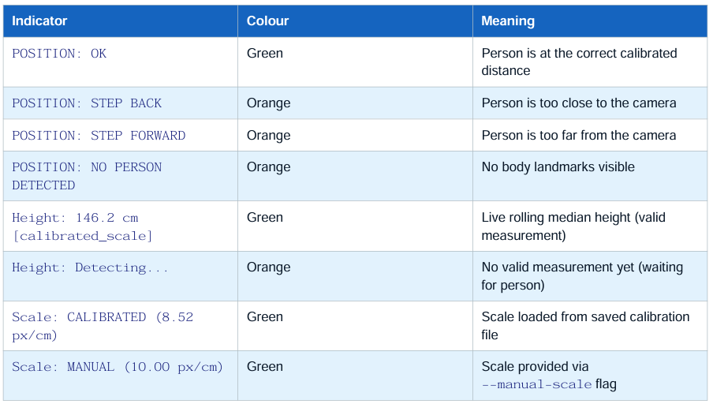

Execution Commands
1.Calibration — Option A: Person Self-Calibration (Most Accurate)
python src/height/pipeline.py --ref-person-cm 146.0 (Replace 146.0 with your actual height in cm.)
Steps:
1. Stand straight on the marked floor spot with your full body visible.
2. The screen shows SPACE: Calibrate to 146.0 cm.
3. Press SPACE to capture. Calibration saves and the window closes automatically

2. Calibration — Option B: Object Calibration python
src/height/pipeline.py --ref-object-cm 27.5 (Replace 27.5 with your reference object's actual height in cm.)
Steps:
1. Place the object vertically on the floor at the exact standing spot.
2. Live camera opens. Press SPACE to freeze the frame.
3. Click the top-left corner of the object and drag diagonally to the bottom-right corner.
4. Press ENTER to confirm and save.
3. Live Person Height Measurement
python src/height/pipeline.py --mode webcam --target person
Steps:
1. Stand on the calibrated floor spot.
2. Check the top overlay — wait for POSITION: OK (green).
3. Stand straight. The bottom of the screen shows your measured height.
4. Press Q or ESC to exit.
4. Live Object Height Measurement
python src/height/pipeline.py --mode webcam --target object
Steps:
1. Place the object you want to measure on the floor spot.
2. The live camera opens. Press SPACE to freeze.
3. Draw a bounding box around the object from top to bottom.
4. Press SPACE again to calculate and display height.
5. Press Q to exit

5. Validation Sweep (Accuracy Test) Technical Documentation
python src/height/validate.py --mode webcam --known-height 146.0 --samples 20
(Replace 146.0 with the test person's actual height.)
Steps:
1. Stand on the calibrated spot. Wait for POSITION: OK.
2. The program automatically collects 20 valid frames.
3. Results printed on screen and saved to src/height/validation_logs/. 8.6 Distance Sensitivity Test python src/height/validate.py --mode distance-test --known-height 146.0
Steps:
1. The program prompts you to stand at close (~1m), medium (~2m), then far (~3m).
2. Press ENTER at each prompt to start collecting samples.
3. A PASS/FAIL table is printed comparing each distance bucket.

7.Manual Scale Override (No Calibration)
python src/height/pipeline.py --mode webcam --target person --manual-scale 10.0

Validation and Testing
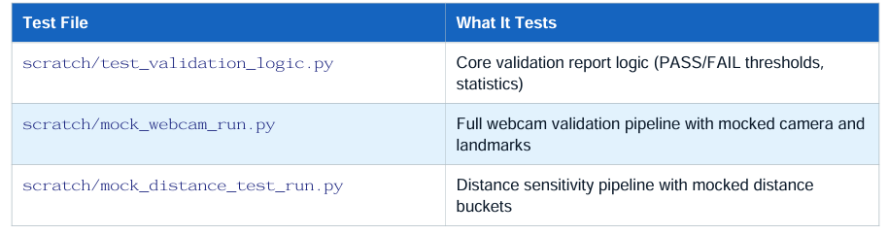
Accuracy and Known Limitations
Accuracy Under Ideal Conditions
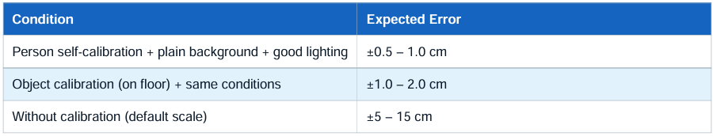

Factors That Improve Accuracy
• Plain, contrasting background (white or grey wall)
• Camera at chest height, lens level (not tilted up or down)
• Good frontal lighting (avoid bright windows behind person)
• Full body visible — head top to toes in frame
• Person standing straight and still on the calibrated spot

Known Limitations

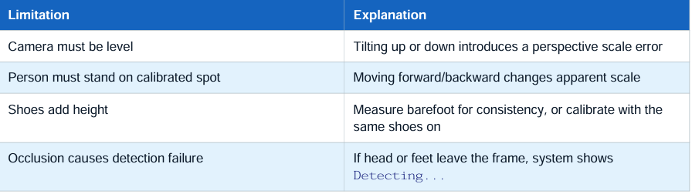

PHASE 2

2. The Core Problem:
When a user stands in front of the mirror wearing loose, baggy, or draped outfits (such as oversized t-shirts, hoodies, wide-leg trousers, or skirts), the silhouette extraction pipeline fails to distinguish between the fabric boundaries and actual anatomical boundaries.
This results in a severe inflation of the visual contour, causing the deep learning model to output inaccurate measurements.

THANK YOU

